


FRIGOGLASS QC
USER MANUAL

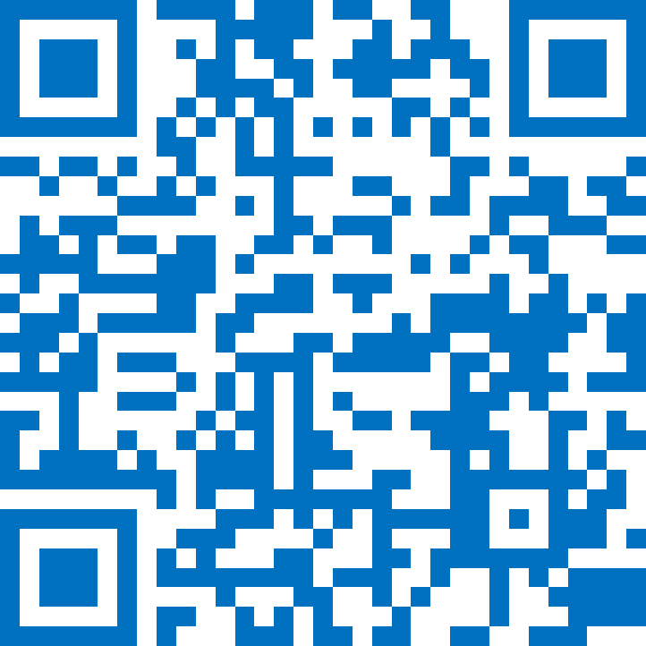
ANDROID APK
Table of Contents
Changelog 3
PURPOSE 4
SCOPE 4
DEFINITION(S) and ABBREVIATION(S) 4
INTRODUCTION 5
Installation of FRIGOGLASS QC Phone AppLICATION (version 1.X) 6
LOGS 11
List of Errors, Alerts, and OK messages 13
Application Version LOG 14
Minimum Requirements for the Phones 14
SUPPORTED Phones 15

Changelog

Version | Date | Author(s) | description of modifications
1.0 | 19.07.2018 | Dimiter Kyurkchiev | Initial Version
1.20 | 01.04.2021 | Akash Panchal | Updated Application Changelog

PURPOSE

- Check the associations Status between coolers and smart devices.

SCOPE

- Useful for Frigoglass QC.

DEFINITION(S) and ABBREVIATION(S)

NAME | ABBREVIATION
BLE | Bluetooth Low Energy
FFA | Sollatek FFA Controller
FFX | Sollatek FFX Smart Device
JEA | Sollatek JEA Controller

INTRODUCTION

Application will:
- Check the associations Status between coolers and smart devices.

Installation of FRIGOGLASS QC Phone AppLICATION (version 1.X)

- Install APK received from a link in android phone.
https://apps.ebest-iot.com/downloads/Android/Frigoglass/

- Click on the FRIGOGLASS QC application icon. It will launch the application.
Note: Before the launching of the Application, please ensure that Bluetooth & Internet are enabled.

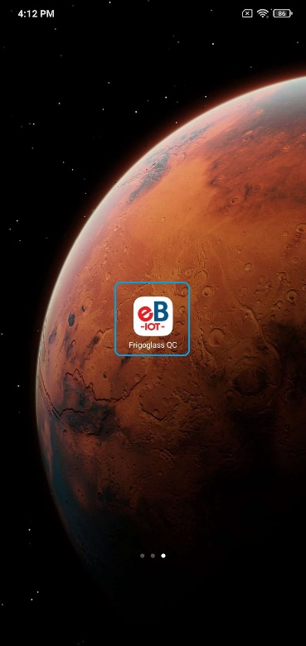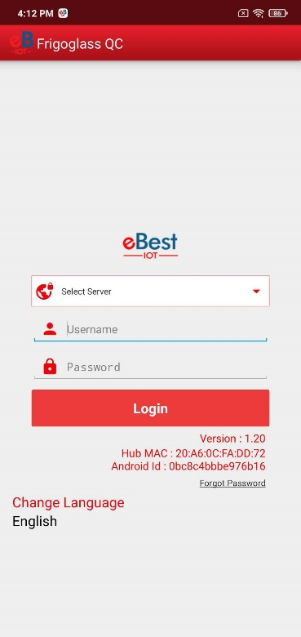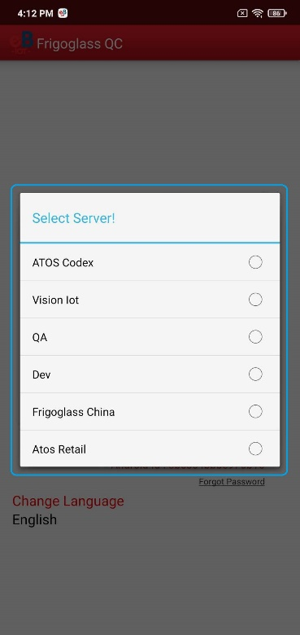

- List of Server shows, depending on the Client and Frigoglass user should choose a different option,
  - For Frigoglass the user can use the Vision IoT server.

- If a user is logging for a first-time Username (User ID) and Password should be entered, and Language should be chosen. The username and password are case-sensitive. Also, users can remember that username and password by Remember Me Option.
- To change the language, tap on Change Language and use can choose the language. Currently, there is English language support available.

- Depending on the Android Version user may get several different prompts to confirm access to the camera, Bluetooth (location services), Storage, etc.
  - The user should Allow all requested for the application to work properly.
- If the user gets a prompt asking to Ignore Battery Optimizations confirm with YES.

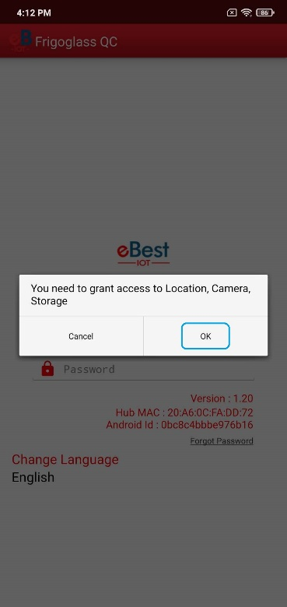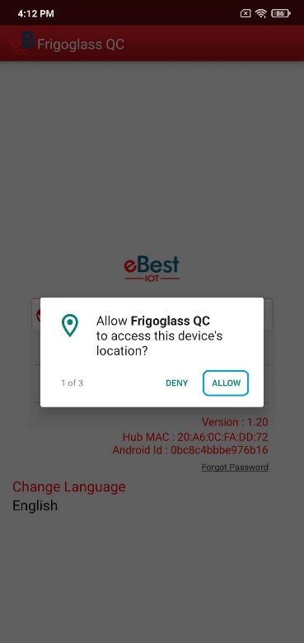

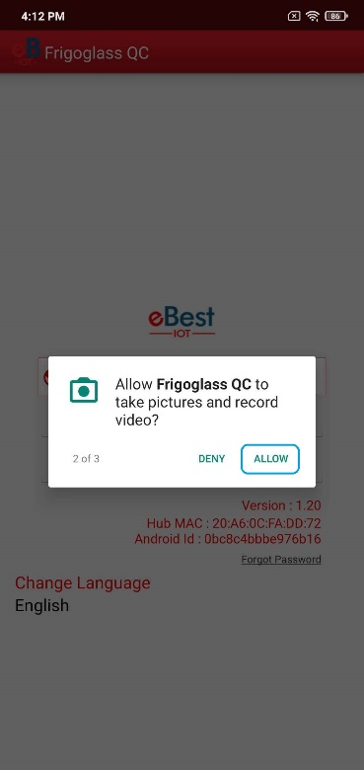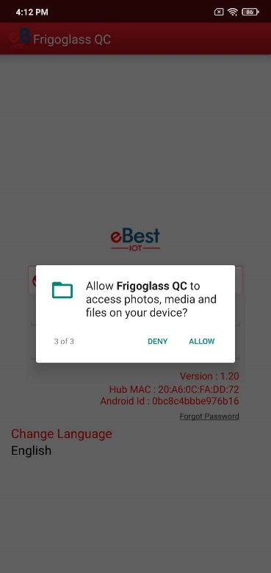

- Provide valid credentials and tap on the Login button, please be advised that the application will need some time to download data from the cloud.

Note: Internet connectivity is required during login otherwise login will fail and the application will not work

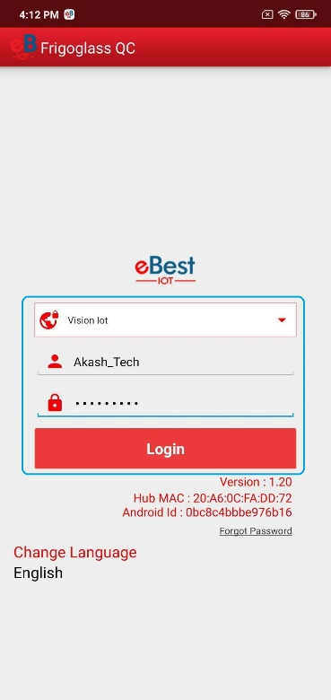
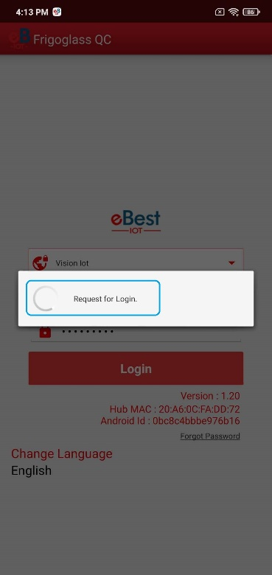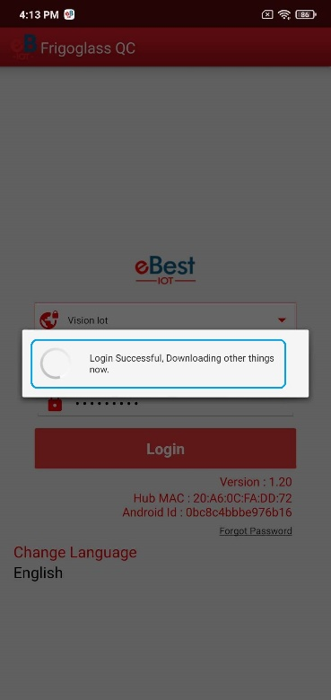
- Tap on SCAN BARCODE and scan the barcode of the cooler. Cooler Serial Number could also be entered manually by taping on ENTER MANUALLY BARCODE.

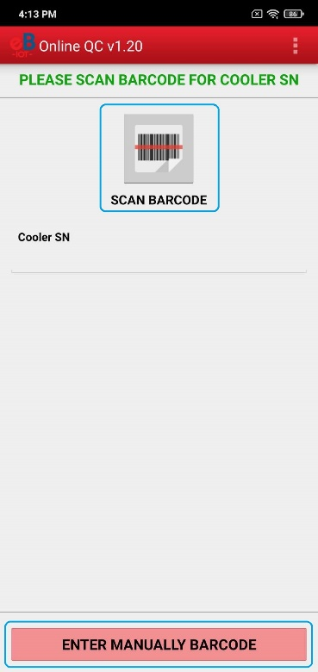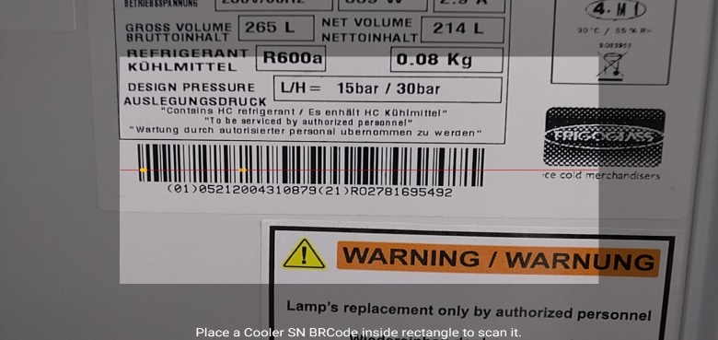
- After the barcode of the cooler is successfully scanned open and close the door of the cooler to wake up the SmartTag and tap again on SCAN BARCODE for Smart Device Serial and scan the barcode of the SmartTag. Smart Device Serial Number could also be entered manually by taping on ENTER MANUALLY BARCODE.
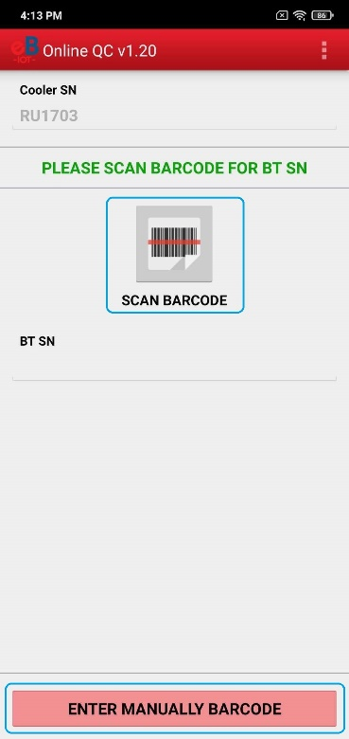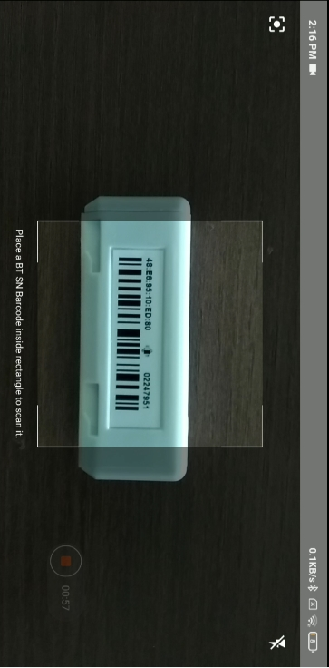
- After the Smart Device Serial Number is successfully scanned the application will check the association in the eBest IoT System. The following message will be shown if the association between the scanned cooler and Smart Device are in the eBest IoT System.

If there is a problem with the association, an Error message will be shown. All the possible Errors and the reasons for them could be seen in the LIST OF ERRORS, ALERTS, AND OK MESSAGES.

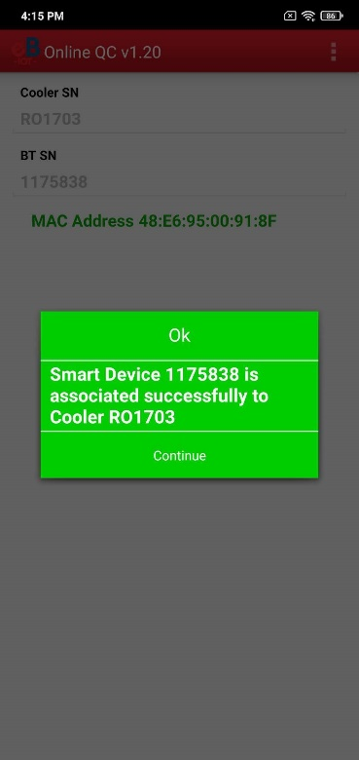

LOGS
- QC DETAILS – To Showing all the Cooler, Smart Device checks done and the results from those checks. If View is tapped, details are shown.

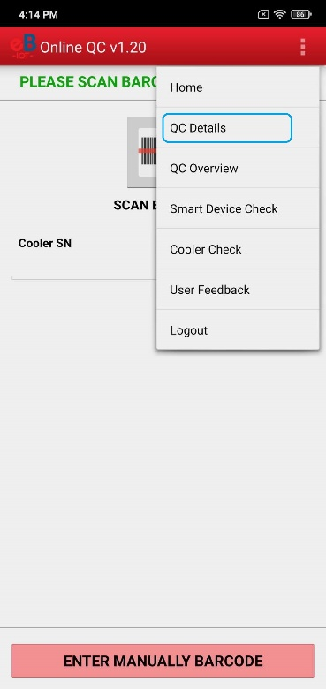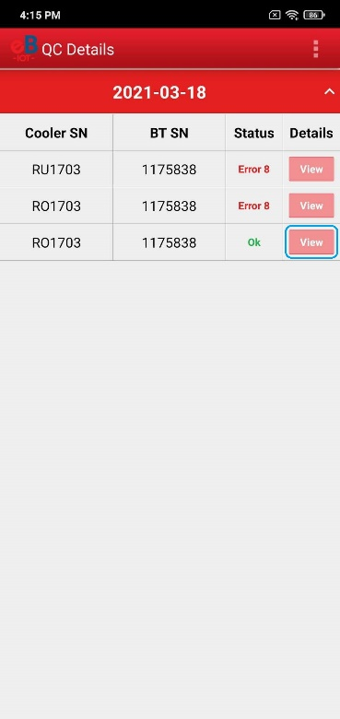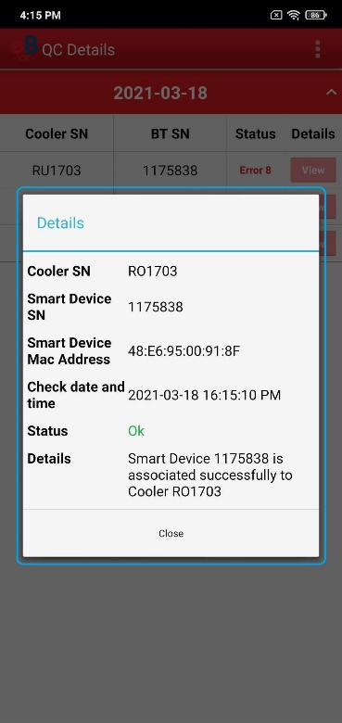

- QC OVERVIEW – To Showing an Overview of the Cooler, Smart Device check Association.
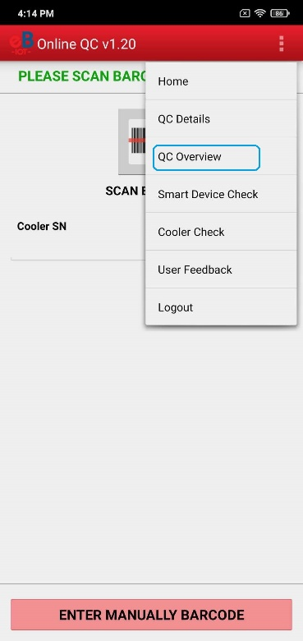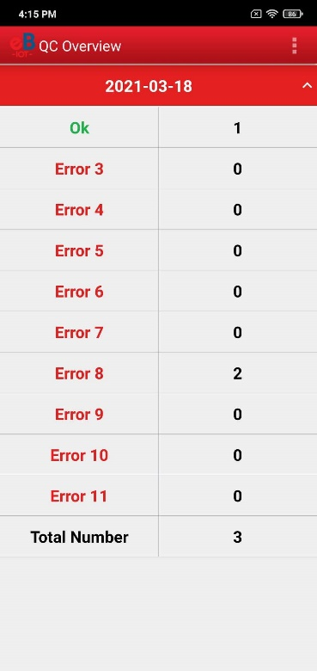
- SMART DEVICE CHECK – To Check a Smart Device without scanning a Cooler.

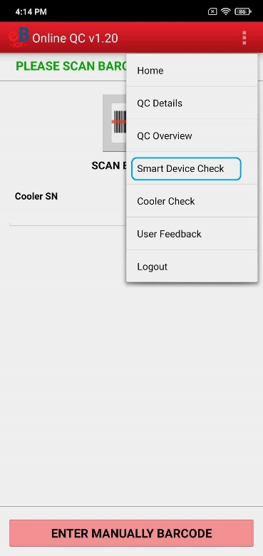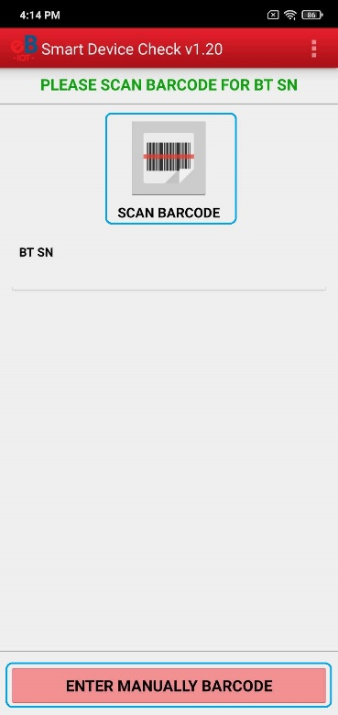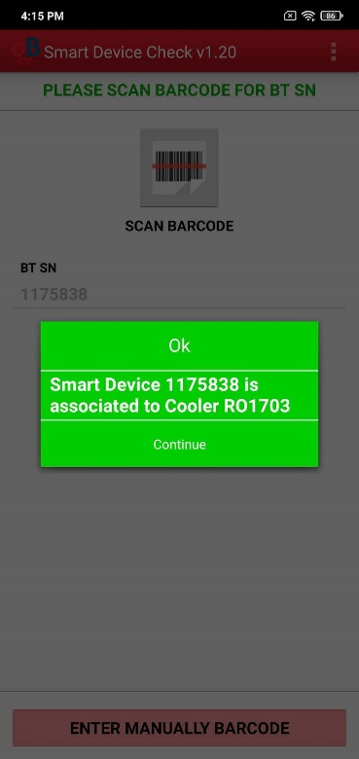

- COOLER CHECK – Check a Cooler without scanning a Smart Device.

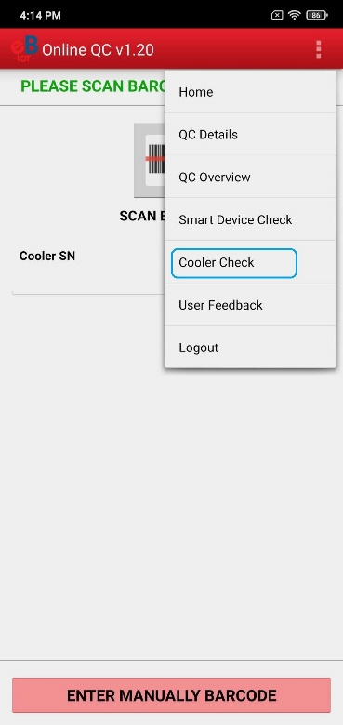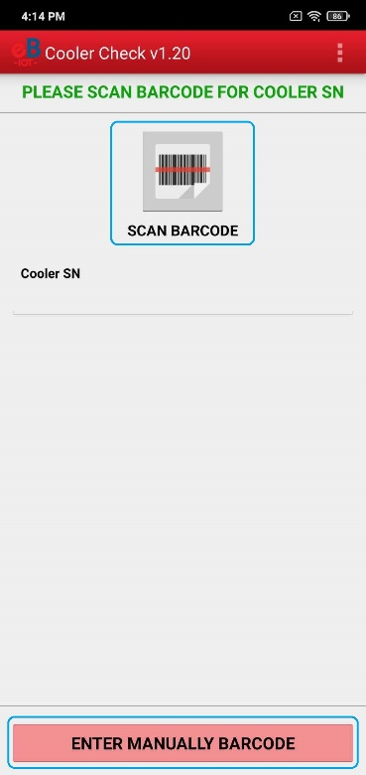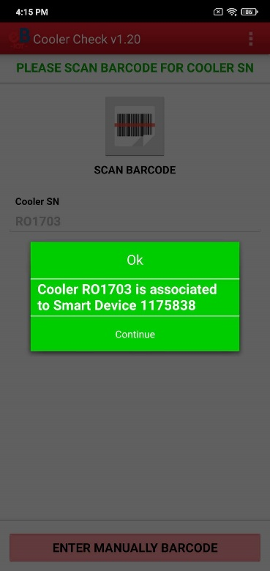

List of Errors, Alerts, and OK messages

Detailed Message | Short Message | User Story
Smart Device <SD SN> is associated successfully to Cooler <COOLER SN> | OK | The user scans the SD SN and Cooler SN, the scanned SD, and Cooler are associated successfully.
Please check your internet connection and try again | ERROR 01 | No Internet
Cannot connect to server, please try again | ERROR 02 | No Internet or server not available
Smart Device <SD SN> is associated to <COOLER SN> and Cooler <COOLER SN> associated to Smart Device <SD SN> | ERROR 03 | The user scans the SD SN and Cooler SN. The scanned SD is associated with a different Cooler than the one scanned.
Smart Device <SD SN> is associated to <COOLER SN> and Cooler <COOLER SN> is not associated | ERROR 04 | The user scans the SD SN and Cooler SN. The scanned SD is associated with a different Cooler than the one scanned. The scanned Cooler is not associated.
Smart Device <SD SN> is associated to <COOLER SN> and Cooler <COOLER SN> is not in the Portal | ERROR 05 | The user scans the SD SN and Cooler SN. The scanned SD is associated with a different Cooler than the one scanned. The scanned Cooler does not exist in the Portal.
Smart Device <SD SN> is not associated and Cooler <COOLER SN> is associated to Smart Device <SD SN> | ERROR 06 | The user scans the SD SN and Cooler SN. The scanned SD is not associated. The scanned Cooler is associated with a different SD than the scanned.
Smart Device <SD SN> and Cooler <COOLER SN> are not associated | ERROR 07 | The user scans the SD SN and Cooler SN, the scanned SD is not associated, the scanned Cooler is not associated.
Smart Device <SD SN> is not associated and Cooler <COOLER SN> is not in the Portal | ERROR 08 | The user scans the SD SN and Cooler SN, the scanned SD is not associated, the scanned Cooler is not in the Portal.
Smart Device <SD SN> is not in the Portal and Cooler <COOLER SN> is associated to Smart Device <SD SN> | ERROR 09 | The user scans the SD SN and Cooler SN. The scanned SD is not in the Portal. The scanned Cooler is associated with a different SD than the one scanned.
Smart Device <SD SN> is not in the portal and Cooler <COOLER SN> is not associated | ERROR 10 | The user scans the SD SN and Cooler SN, the scanned SD is not in the Portal, the scanned Cooler is not associated.
Smart Device <SD SN> and Cooler <COOLER SN> are not in the Portal | ERROR 11 | The user scans the SD SN and Cooler SN, the scanned SD is not in the Portal, the scanned Cooler is not in the Portal.
SMART DEVICE CHECK
Smart Device <SD SN> is associated to Cooler <COOLER SN> | OK | The user scans the SD SN, the scanned SD is associated with Cooler SN.
Smart Device <SD SN> is not associated | ERROR 12 | The user scans the SD SN, the scanned SD is not associated.
Smart Device <SD SN> is not in the Portal | ERROR 13 | The user scans the SD SN, the scanned SD is not in the Portal
COOLER CHECK
Cooler <COOLER SN> is associated to Smart Device <SD SN> | OK | The user scans the Cooler SN, the scanned Cooler is associated with SD SN.
Cooler <COOLER SN> is not associated | ERROR 14 | The user scans the Cooler SN, the scanned Cooler is not associated.
Cooler <COOLER SN> is not in the Portal | ERROR 15 | The user scans the Cooler SN, the scanned Cooler is not in the Portal

Application Version LOG

Version | Date | Changes
1.22 | 18.01.2021 | Resolved Issue in GMC5 Check menu
1.21 | 23.12.2020 | Login page show Gateway HUB and Android id Details.  App Info get Gateway HUB from a single method  An issue in Error Message
1.20 | 21-12-2020 | Rename QC Application
1.19 | 28-09-2020 | Add Gateway HUB and Android id info on Login Screen
1.18 | 11-09-2020 | Update to latest Bugfender SDK
1.17 | 11-02-2020 | The factory app and the Frigoglass app are currently overlapping
1.16 | 10-05-2019 | support for Indonesia Cooler Serial Numbers
1.15 | 18-04-2019 | Bar code Enhancement in Association app and QC app for Frigoglass India
1.14 | 20-02-2019 | Introduce Factory Selection screen in the QC App
1.13 | 15-01-2019 | Added support for the "IN" barcode in Cooler Serial Number scanning
1.12 | 08-01-2019 | Bugfender SDK 1.1 Integration in Quality Control App  Update barcode scanning implementation and library
1.11 | - | Changed Association Check URL from InfoV2 to infoV2
1.10 | - | Changed error code for Smart Device check and Cooler Check
1.9 | - | Added support for Localization
1.8 | - | Changed default strings for no internet connection and when a server is not responding
1.7 | - | Resolved error 1 was not generated when there was no internet  Changed success message title from 'Success' to 'OK'
1.6 | - | Added individual check for Smart Device SN and Cooler SN
1.5 | - | Added QC Details and Overview with proper error message structure
1.4 | - | Disable Offline module
1.3 | - | Remove Unassigned device List checking logic from Online QC
1.2 | - | Bug Fixes  - Disconnection and auto disconnection of device Issue and popup Message issue resolved  - Device Connection related issue resolved.  - OK Message related issue resolved after killing the QC Application.
1.1 | - | Added QC module for checking association data from cloud-side
1.0 | - | Added Frigoglass QC module and checking Cooler SN in BLE Device

Minimum Requirements for the Phones

Component | Minimum Required
Operating system | Android 6.0 (Marshmallow)
Operating memory (RAM) | 2 GB to 4 GB or more
Free Storage | 2 GB
Camera | At least 5.0 MP with Autofocus
Processor (CPU) | A quad-core processor or faster
Bluetooth | BLE 4.1 and above

SUPPORTED Phones
  - Alcatel Pixi 4
  - Asus Zenfone Go (ZB500KL)
  - Asus Zenfone Max Pro M1
  - Google Pixel 3a
  - One plus 3T (A3003)
  - Samsung Galaxy A10
  - Samsung Galaxy S5
  - Samsung Galaxy S7
  - Samsung's Galaxy Xcover 4 SM-G390F
  - Xiaomi Redmi 4
  - Xiaomi Redmi 6 Pro
  - Xiaomi Redmi Note 4

